**S3 Static Web Hosting**

Sign in to the AWS Management Console and open the Amazon S3 consoleat [https://console.aws.amazon.com/s3/](https://console.aws.amazon.com/s3).

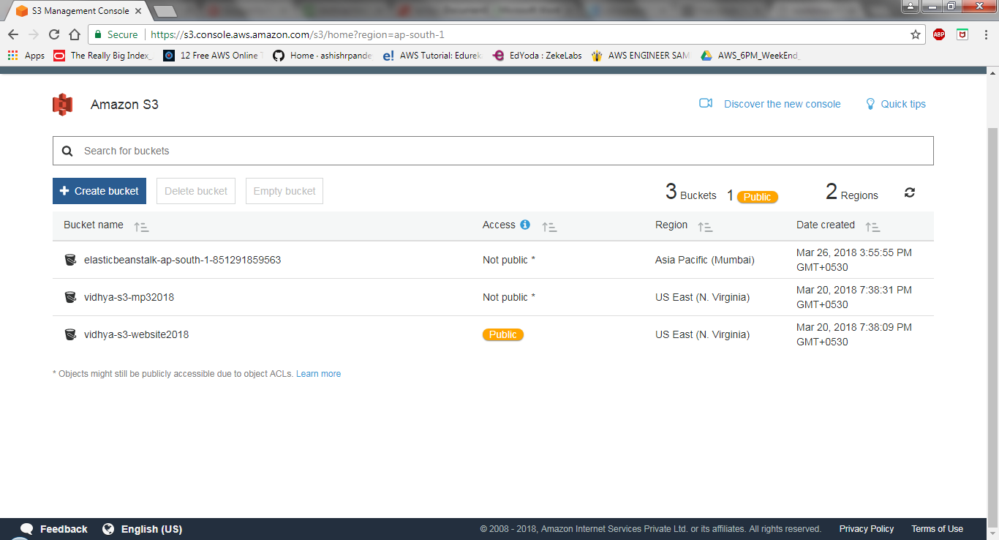

On the name and region page, type a name for your bucket and choose the AWS Regionwhere you want the bucket to reside. Name of your bucket should be unique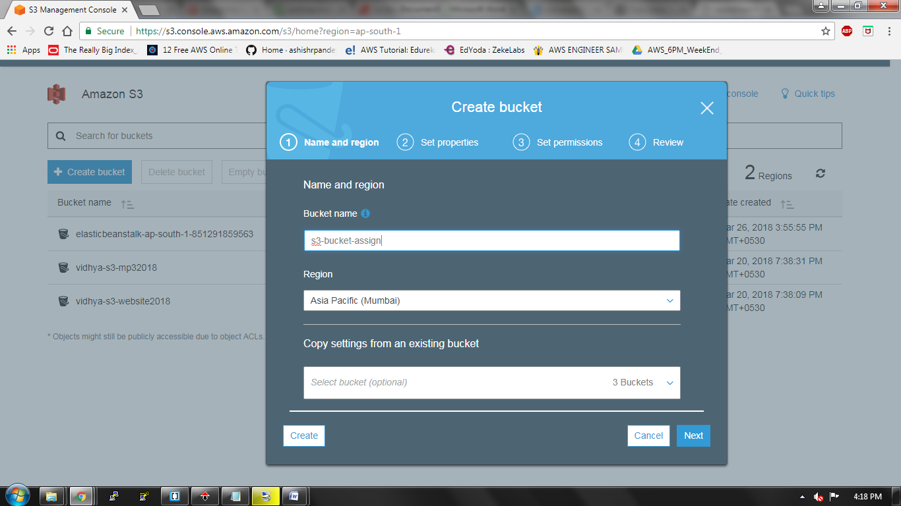

 A tag is a key-value pair that represents a label that you assign to a bucket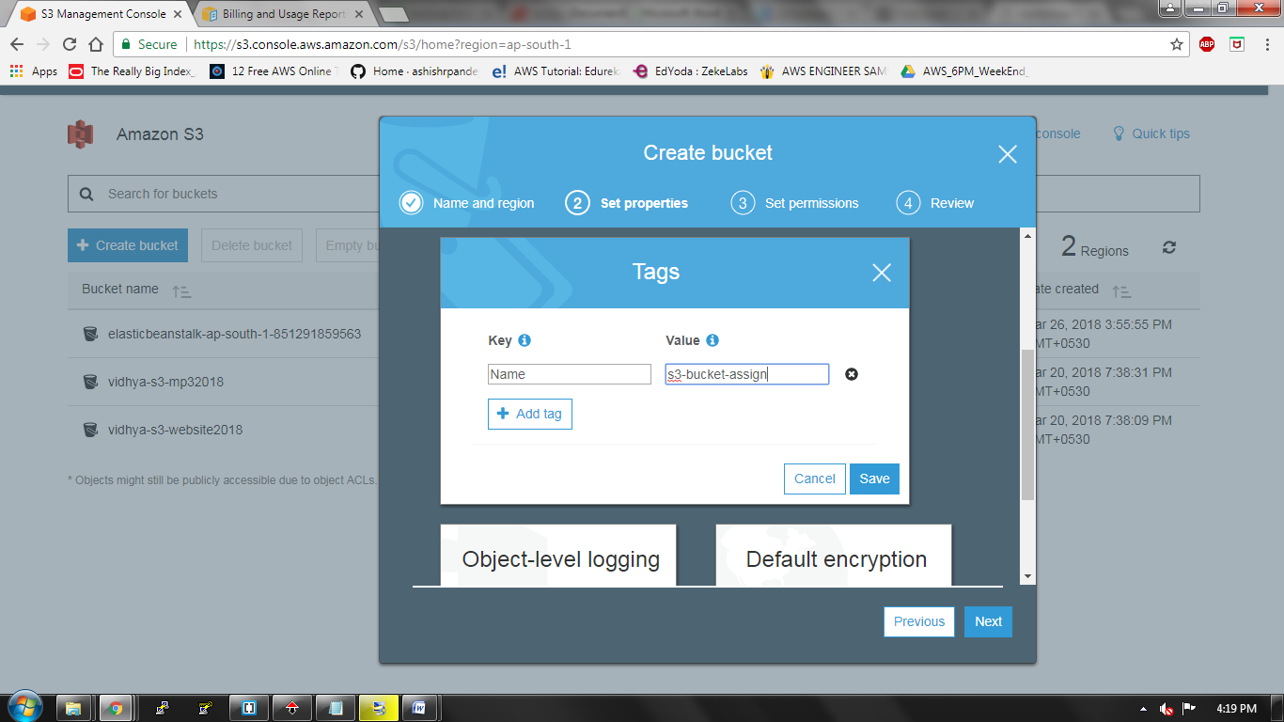

On the set permissions page, you manage the permissions that are set on the bucket thatyou are creating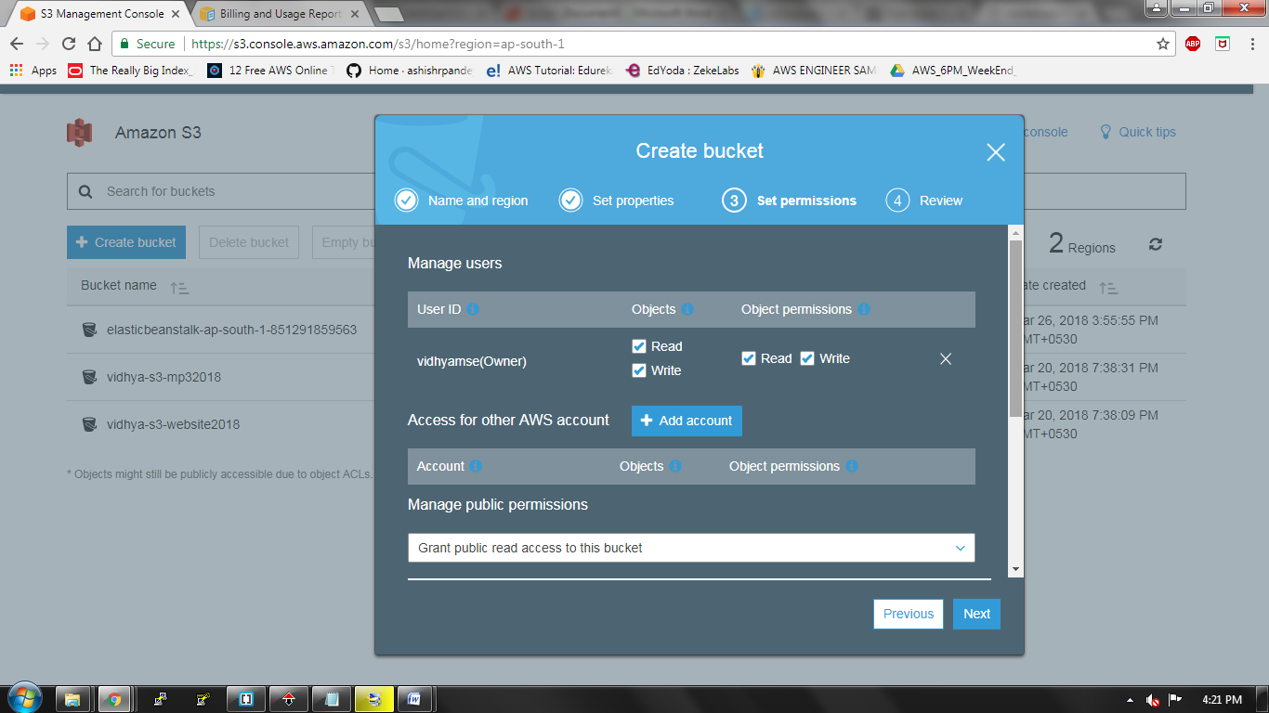

On the review page, verify the settings. If you want to change something, choose edit. Ifyour current settings are correct, choose create bucket

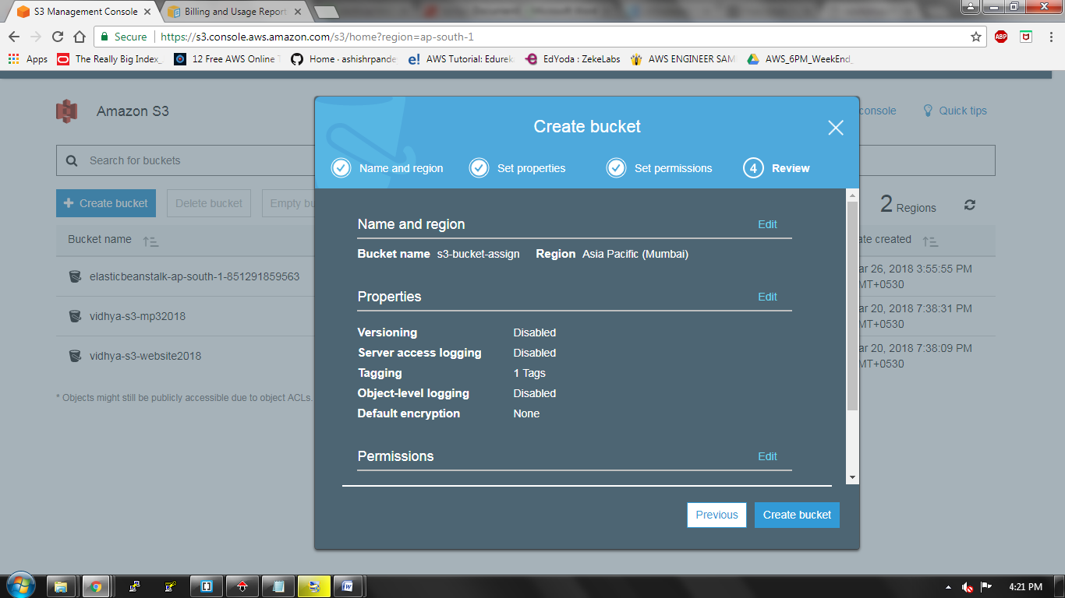

In the properties pane for the bucket, choose static web hosting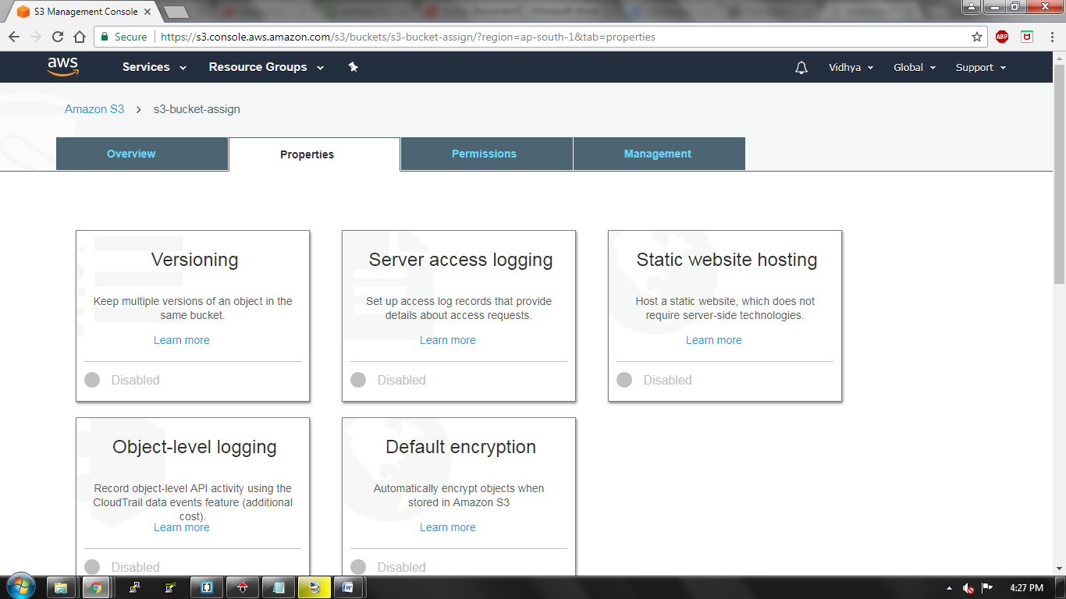

Create index.html and copy the end point link. Save the settings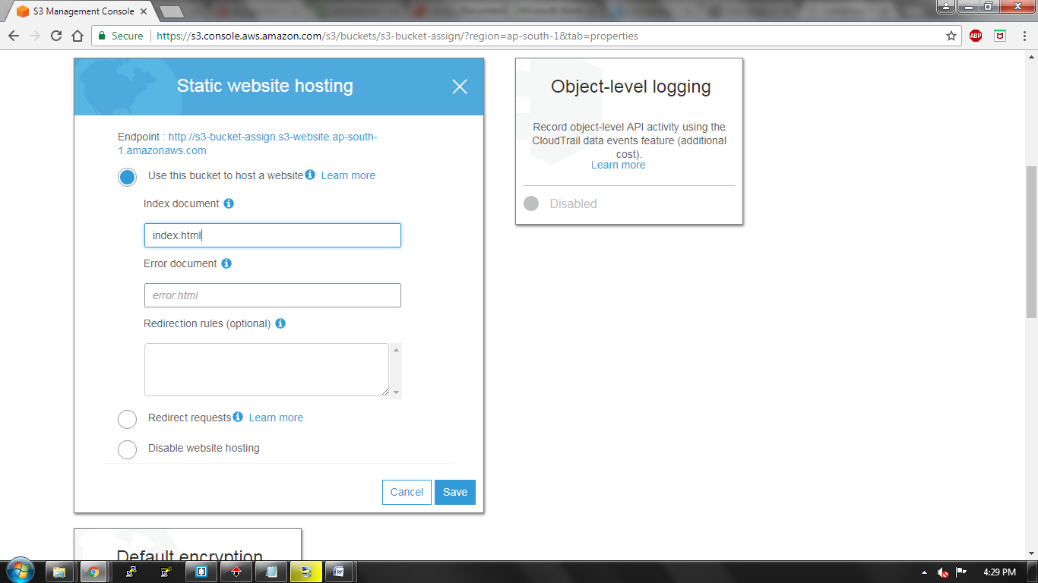

In permissions pane of your s3 bucket give the access for your AWS account and save it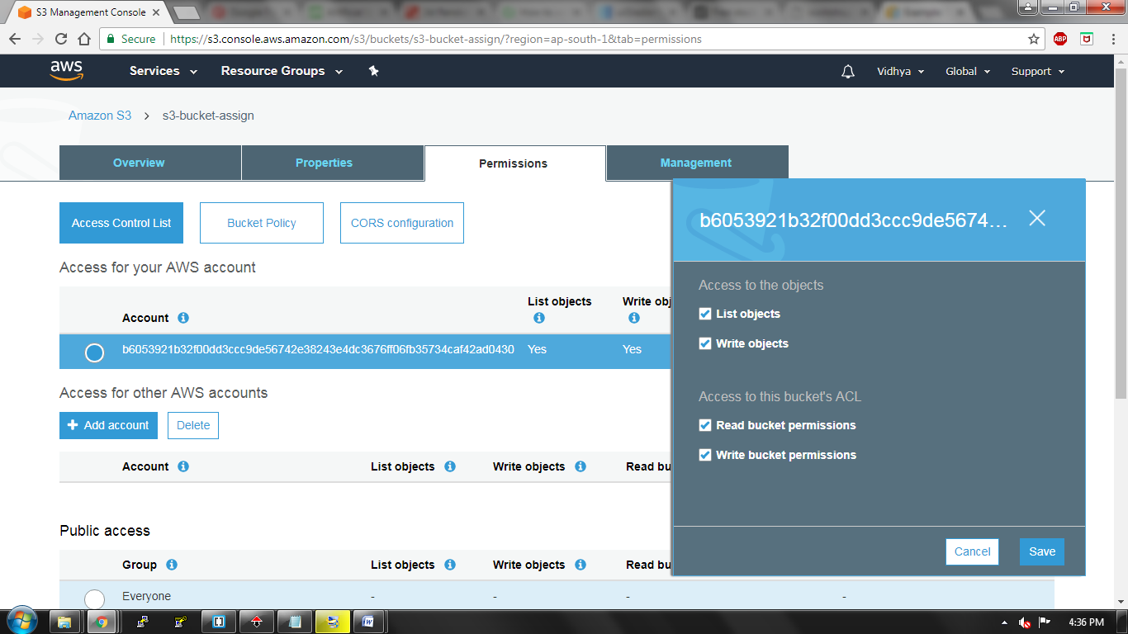

Create index.html page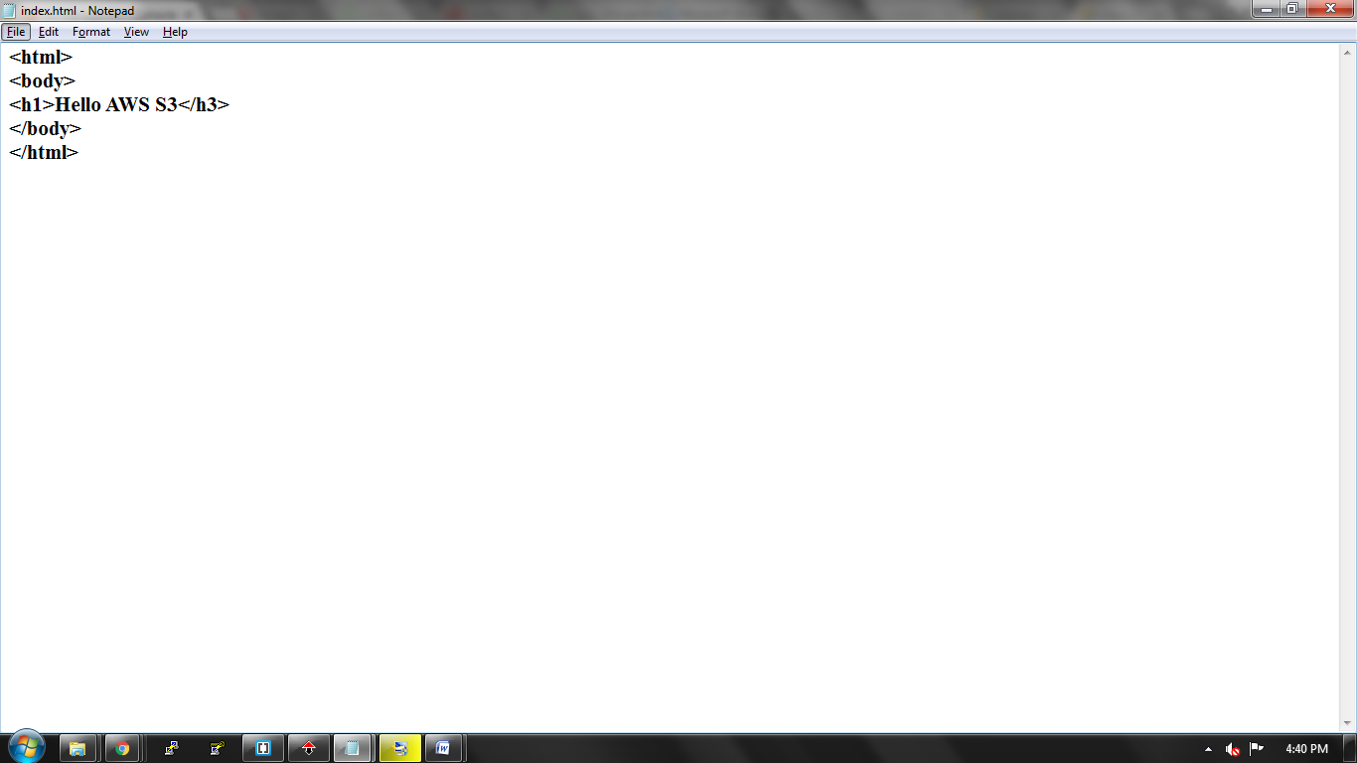

Upload your index.html file in your S3 bucket

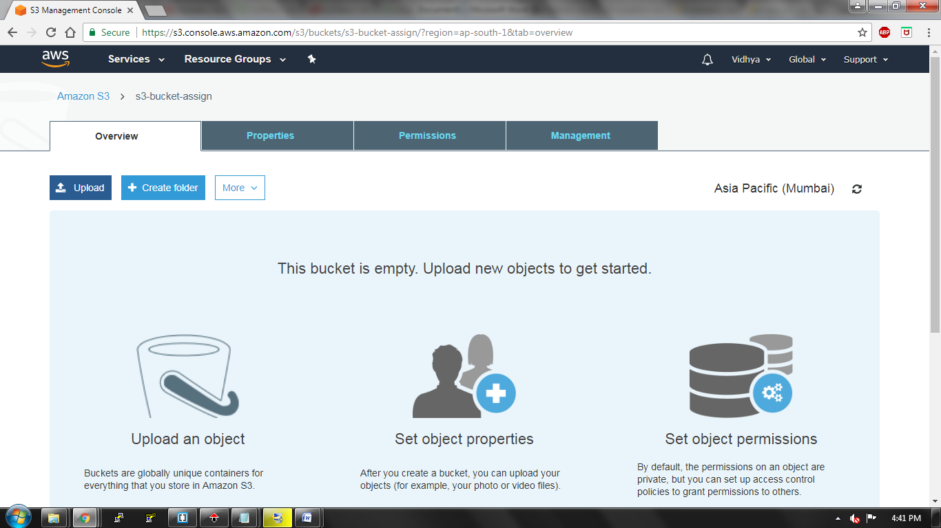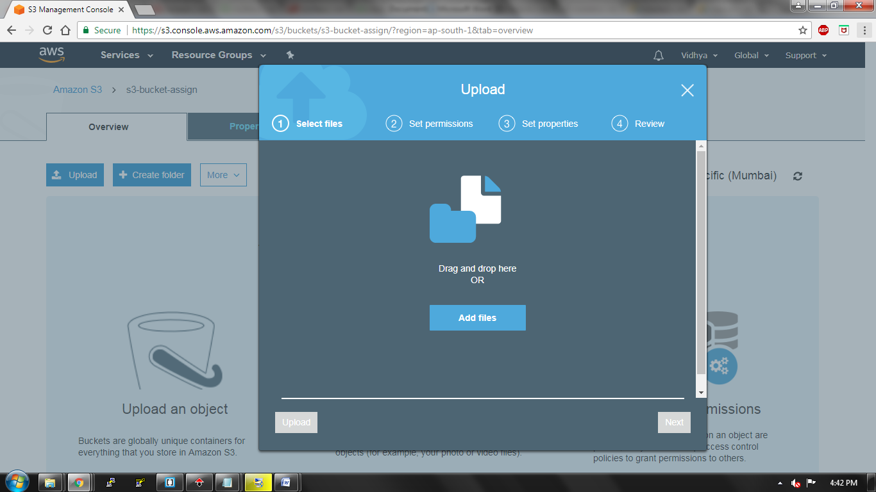

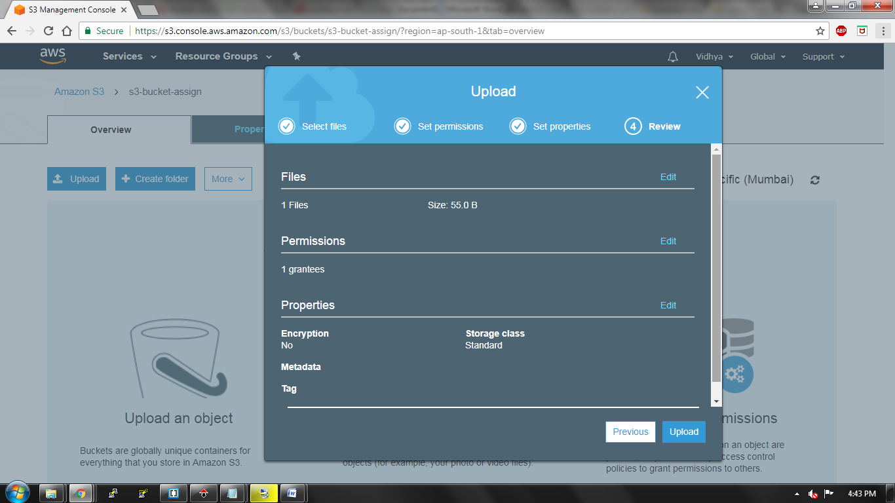

In the permissions pane of your index.html make it as public.

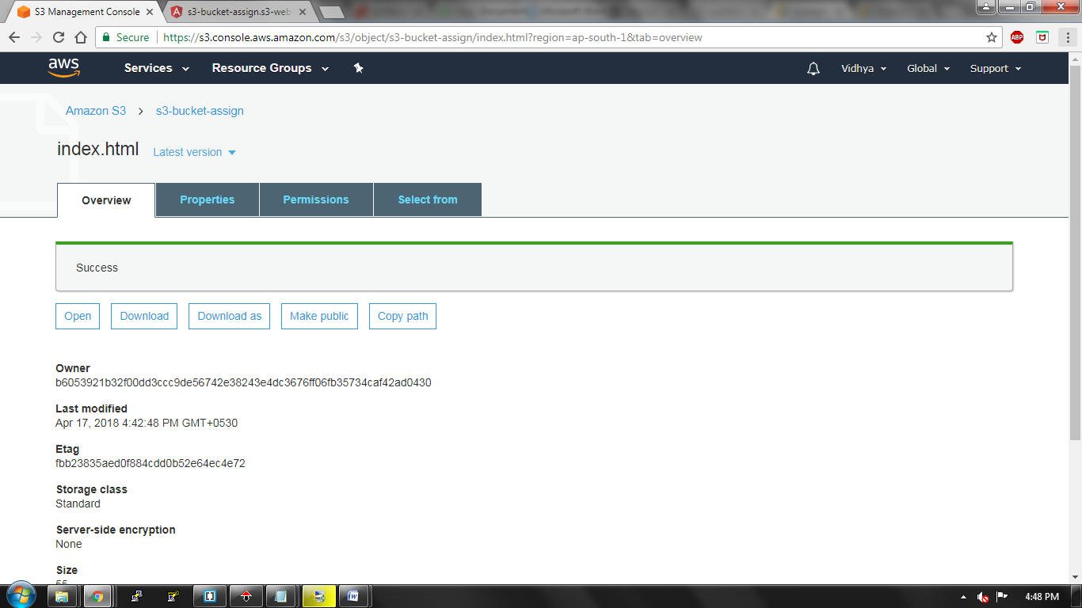

Go to your browser and give the endpoint link which you have copied in static web hosting page andload your webpage. 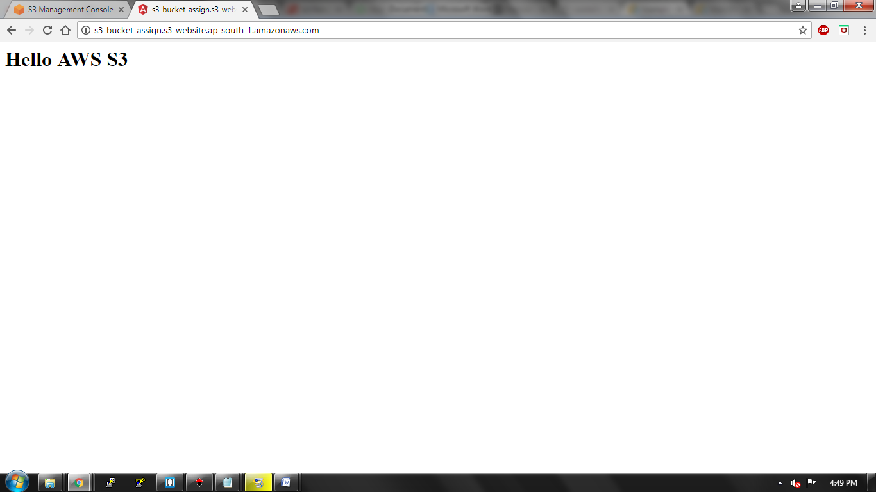

**Create a lifecycle rule**

Click on Lifecycle in management pane of your S3 bucket

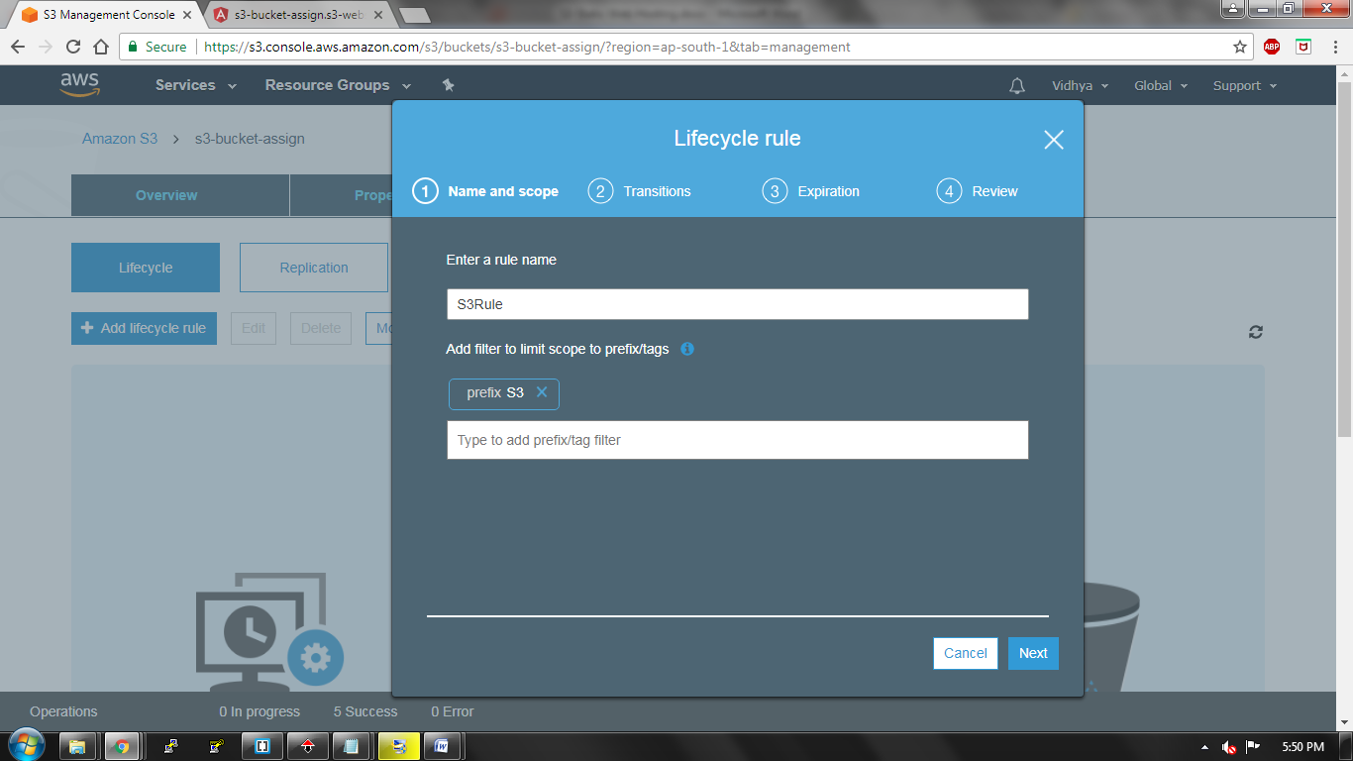

Configure your transition whether it is your current version or previous version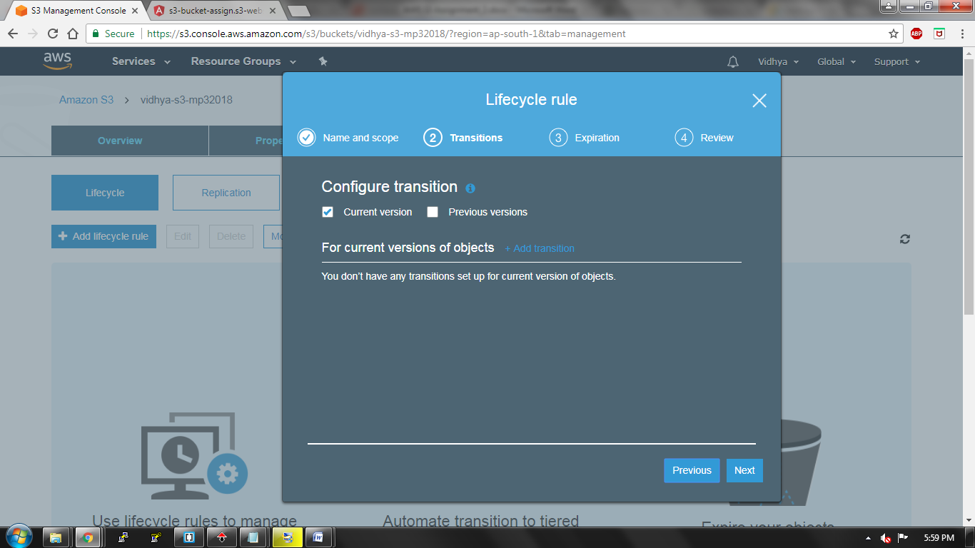

Add transition rule so that your data older than 45 days moves to Standard-IA and data older than 100days gets archived in glacier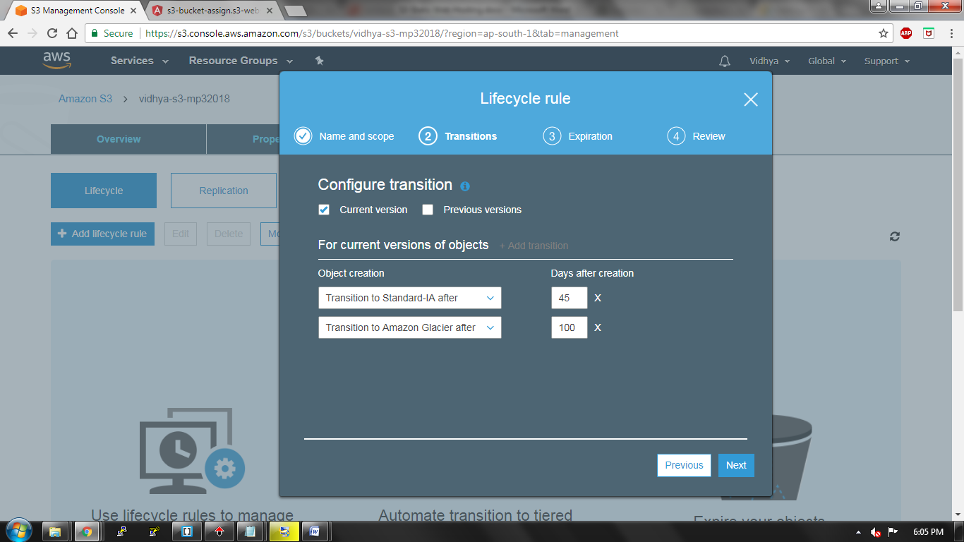

Clean up expired object, delete markers and incomplete multipart uploads after 7 days of upload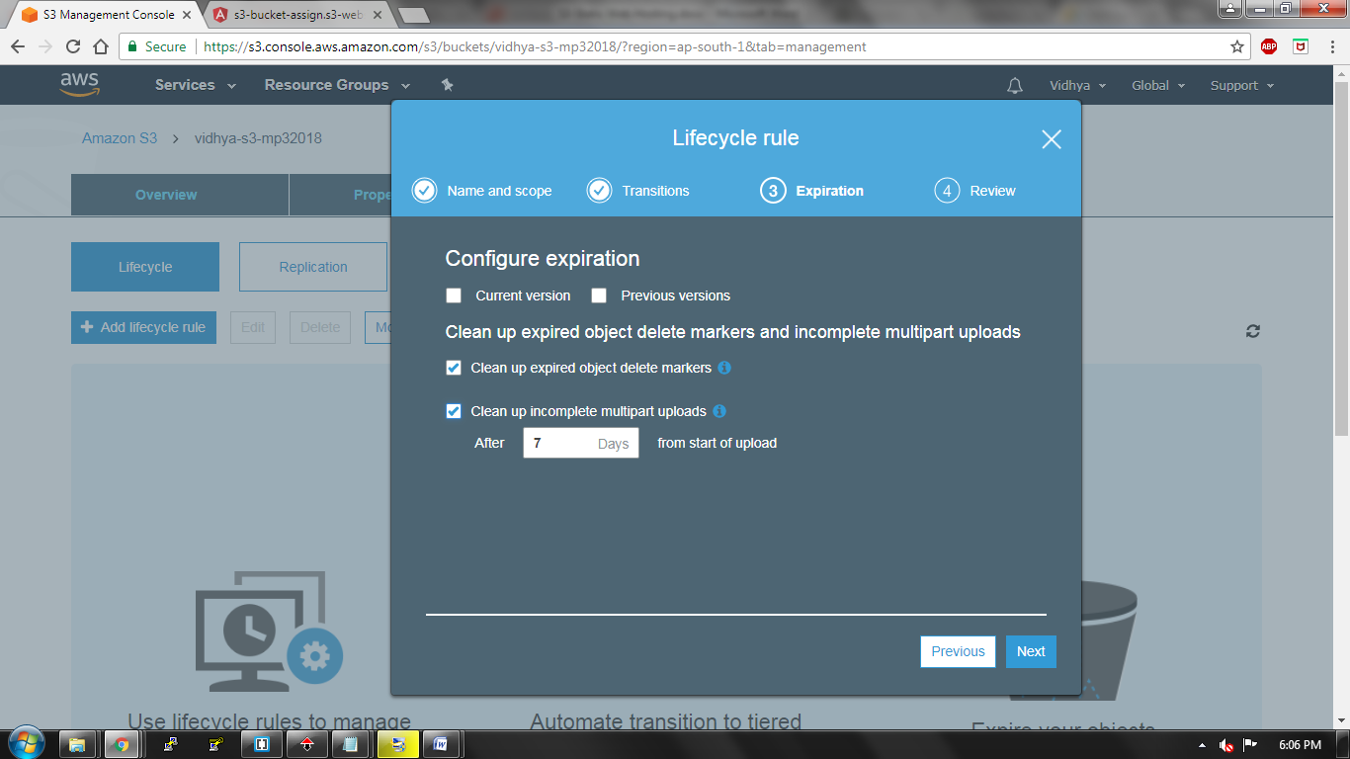

Review your lifecycle rules and save your changes